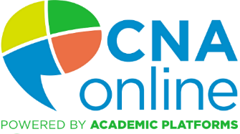**

* Attract more students with flexible online theory training
* Academic Platforms provides an online instructor to assist students througout the course
* Your nurse instructor is not required to teach or prepare for theory hours
* Your nurse instructor conducts clininal hours
* Students can continue to work at your facility while doing online work during their off hours
* Students can study anytime, anywhere, with any device including smart phones
* E-Book, audio book, videos, quizzes, study course, and tests

PRE-CERTIFICATION Nurse Assistant Training

* AHCA BEST OF BREED CURRICULUM “*HOW TO BE A NURSE ASSISTANT”*
* BEST OF BREED LMS “CANVAS”
* STATE APPROVED
* START A CLASS ANYTIME
* DATA ANALYTICS CAPTURE STUDENT PROGRESS & REPORTING
* COMPETENCY-BASED SKILLS CHECKLISTS

C

**We have partnered with Academic Platforms to make it easier for our member facilities to grow their own workforce with online clinical education**

Contact Academic Platforms for a demo to see if this program is a good fit for your facility

1. Complete state application to become a facility-based training center (**Place application link here)**
2. If you are already an approved center (**place instructions here)**
3. Instructor qualifications **(Place link here or list qualifications)**
4. Lab requirements **(Place link here or list requirements)**

**NEXT STEPS**

for additional information visit <HTTPs://cnaonline.com/facilities>

Reach out to academic Platforms to schedule a demo and determine if this program suits your facility’s needs Or email: [Gwynette.Winstead@academicplatforms.com](mailto:Gwynette.Winstead@academicplatforms.com)